Including people aged 50 and over in the DHS – HIV

As noted by UNAIDS in 2013 an increasingly significant trend in the global HIV epidemic is the growing number of people aged 50 years and older, who are living with HIV. UNAIDS notes that this trend has important implications for HIV responses, yet it remains a largely hidden dimension of the epidemic. It is hidden because of the lack of data available. With DHS the source of data for prevalence estimates and a number of the GARPR indicators, a huge amount of HIV data has been restricted to people between the ages of 15-49.

With growing numbers of people aged 50 and over living with HIV, we now face an ageing epidemic and much more comprehensive data is needed to inform an evidence based and age-appropriate response. Expanding DHS to include men and women over the age of 49 is necessary to achieve this.

In the US it is projected that people aged 50 and over will constitute 50% of people living with HIV by 2015. In sub-Saharan Africa current figures suggest people in this age group already constitute significant proportions of all people with HIV (35% in Madagascar, 24% in Lesotho, 20% in Zambia, 19% in Malawi, Swaziland and Uganda). The 2007 and 2012 Kenya AIDS Indicator Surveys included women and men up to the age of 64. The findings of the 2012 survey show prevalence is highest in the 45-54 year age group. Better data is needed to ensure accurate prevalence estimates and a clearer understanding of older people’s risks and access to services and support.

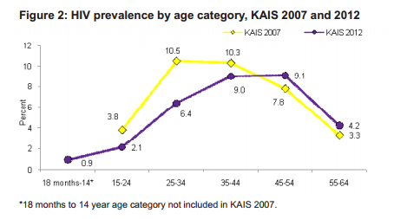

Where HIV data is available on people aged 50 and over it indicates some of the challenges to be addressed and makes the case for more systematic data collection. For example:

- Data shows older people are less likely to practice safer sex than younger people. For example, in Nigeria 4.7% of men aged 50-59 who had 2 or more partners in the previous 12 months used a condom at last sex, compared with 33.1% of men aged 15-49. Similar differences are seen across numerous countries with data available, and show the need for more targeted education and information with men in their 50s and over.

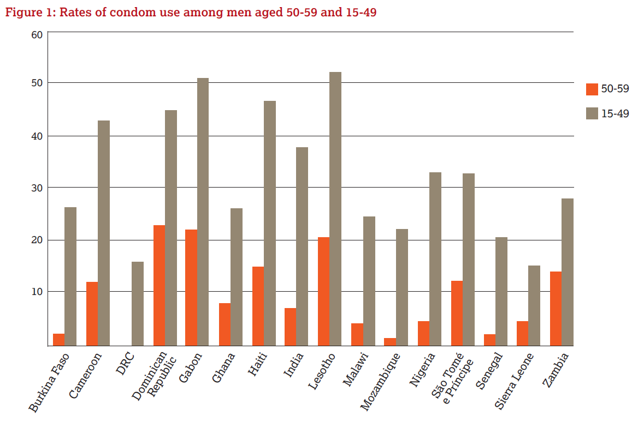

- Data shows older people are less likely to go for an HIV test than younger people, and older people are therefore more likely to be diagnosed late with implications for the effectiveness of treatment. When offered an HIV test at home or in a way deemed appropriate to them, older people are willing to test for HIV. Including women and men aged 50 and over in DHS, including in testing for HIV, would help to overcome the challenges of late diagnosis and older people’s lack of awareness of their HIV status.

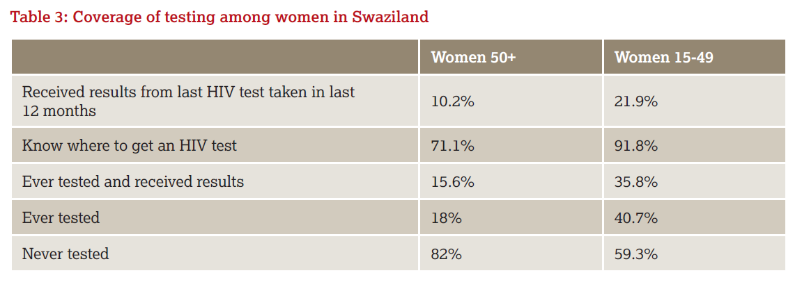

- Data shows older people are less likely than younger people to express accepting attitudes towards people living with HIV. This indicates the need for more focussed awareness raising with people in older age in order to challenge and overcome stigma and discrimination faced by people living with HIV.

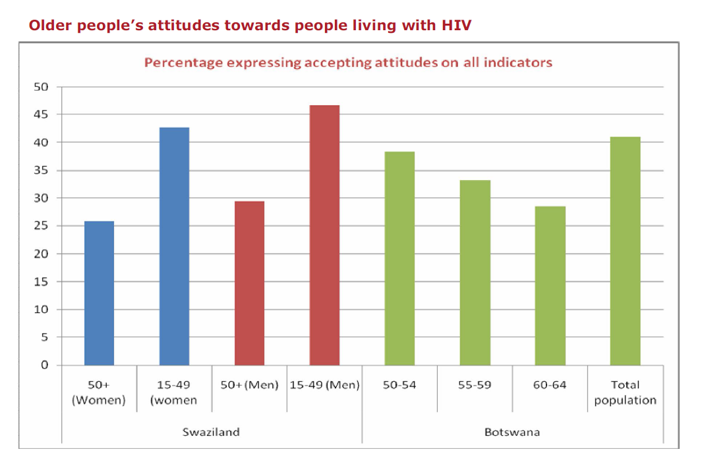
Including people aged 50 and over in DHS and collecting data on their views and experiences in relation to HIV, would provide a vitally needed and strengthened evidence base from which to ensure HIV responses can meet the needs of all affected populations in an appropriate and effective way.

UNIADS ‘HIV and Aging: a special supplement to the UNAIDS report on the global AIDS epidemic’ in 2013
Centers for Disease Control Surveillance data
Negin J and Cumming R 2010 HIV infection in older adults in sub-Saharan Africa: extrapolating prevalence from existing data, Bulletin of the World Health Organisation, 2010;88:847-853
Kenya National AIDS and STI Control Programme, Ministry of Health, 2013 Kenya AIDS Indicator Survey 2012 Preliminary Report
National Population Commission Federal Republic of Nigeria 2009 Demographic and Health Survey 2008
HelpAge International 2013 Including older women and men in HIV data
Government of Swaziland, Demographic and Health Survey 2006-07, Mbabane, Central Statistics Office, 2008
Cuzin L et al, “Immunological and clinical responses to highly active antiretroviral therapy in patients with HIV infection aged > 50 years”, Clinical Infectious Diseases, 45, 2007, pp. 654-657
See 7
Botswana Central Statistics Office 2009 Botswana AIDS Impact Survey III 2008

