DHS results:

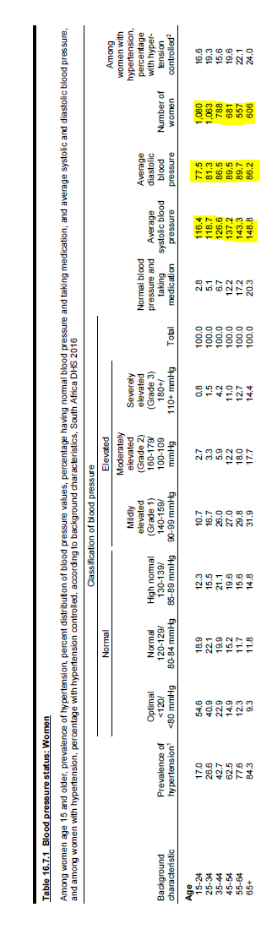

 |  | SysBP_W_average
 |  | Mean | Adjusted Valid N | Valid N
age groups | 15-24 | 116,68 | 1063 | 1063
 | 25-34 | 118,98 | 1022 | 1022
 | 35-44 | 127,18 | 765 | 765
 | 45-54 | 136,98 | 681 | 681
 | 55-64 | 143,65 | 553 | 553
 | 65+ | 149,04 | 597 | 597

