The Demographic and Health Surveys Program
Revising the DHS Model Questionnaires, Optional Modules, and Biomarkers for DHS-8

How to Register in the DHS Program User Forum
1. All suggestions for revising DHS model questionnaires, optional modules, and biomarkers should be submitted via the DHS Program User Forum on Questionnaire Review for DHS-8.
http://userforum.dhsprogram.com/
(Registration is not required for reading the contents of the forum).
2. Registration is required to post to the Forum. Click on “Register” to register in the User Forum:
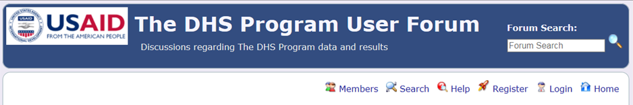
3. Read the rules and policies of the User Forum. If you agree to the terms, press the Agree button at the end of the page:
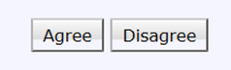
4. Provide the Registration Information that is Required:
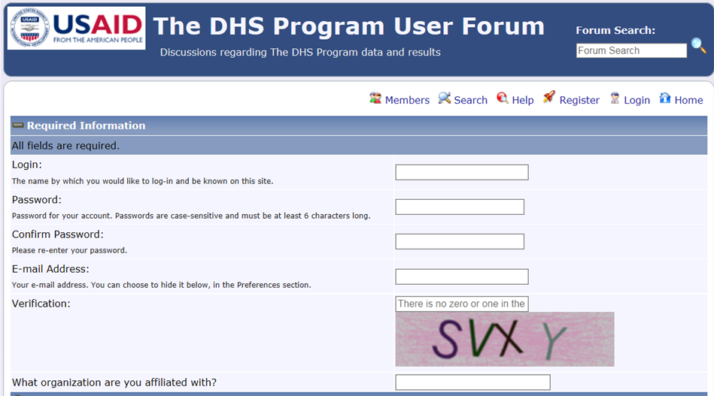

5. At the bottom of the Registration page, under “Preferences” please provide a Signature. A Signature will appear at the bottom of your postings. While a signature is optional in the User Forum, we are asking that ALL people who post in the Questionnaire Review Forum provide a signature so that all postings are identified.
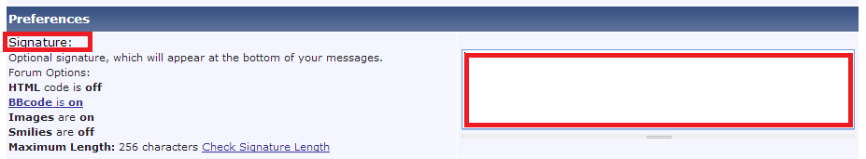
The Signature should include your Name and Organization, such as:
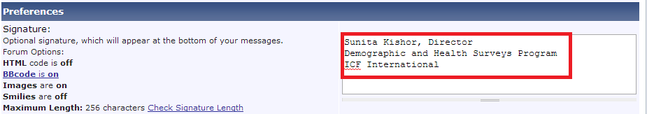
6. Other Settings can remain at the default settings. Click “Register” at the bottom of the page:
7. After you Register, you will be sent an email from forums@dhsprogram.com to confirm your registration. Click on the URL provided in the email to confirm. (This step is necessary to avoid spam registrations).

8. You will then be able to post your input to the appropriate topic folder. You can also comment on other postings.
9. If you have questions, email us at dhsqre@dhsprogram.com

